COGNIZANT DEEP SKILL
WEEK 1

Module 1: Design Patterns and Principles

Exercise 1: Implementing the Singleton Pattern
- Creating Logger Class
- Implementing Singleton Pattern
- Testing Singleton Implementation
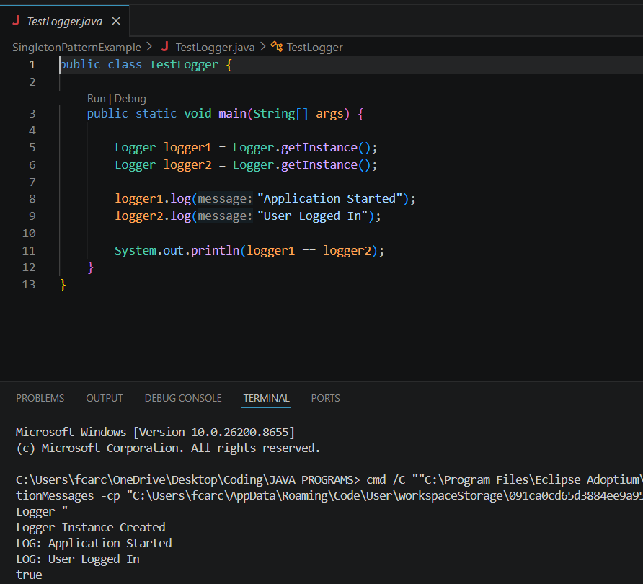

Exercise 2: Implementing the Factory Method Pattern
- Creating Document Interface
- Creating Concrete Document Classes
- Implementing Factory Method
- Testing Factory Pattern
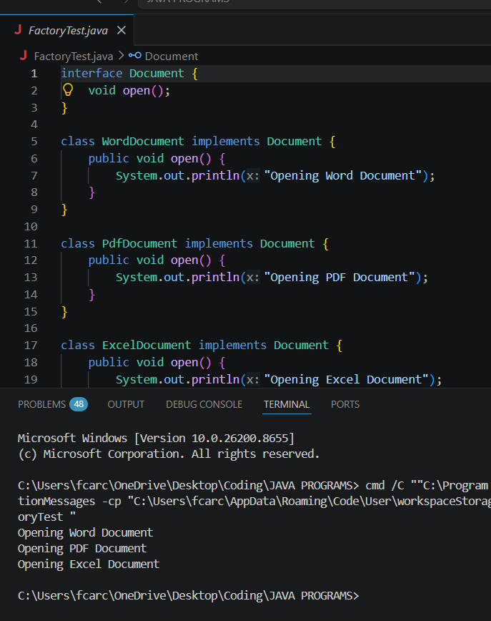

Module 2: Data Structures and Algorithms

Exercise 3: E-Commerce Platform Search Function
- Big O Notation
- Product Class Creation
- Linear Search Implementation
- Binary Search Implementation
- Complexity Analysis
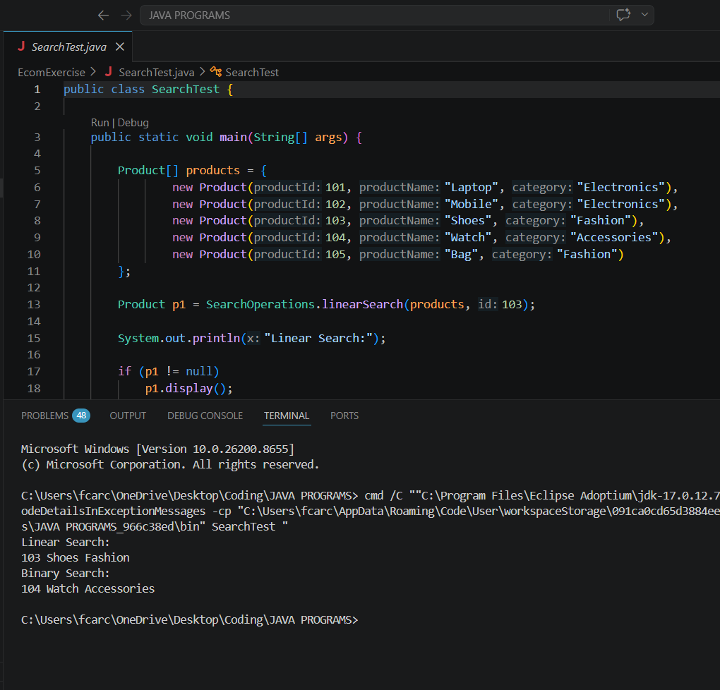

Exercise 4: Financial Forecasting
- Understanding Recursion
- Recursive Future Value Prediction
- Complexity Analysis
- Optimization Techniques

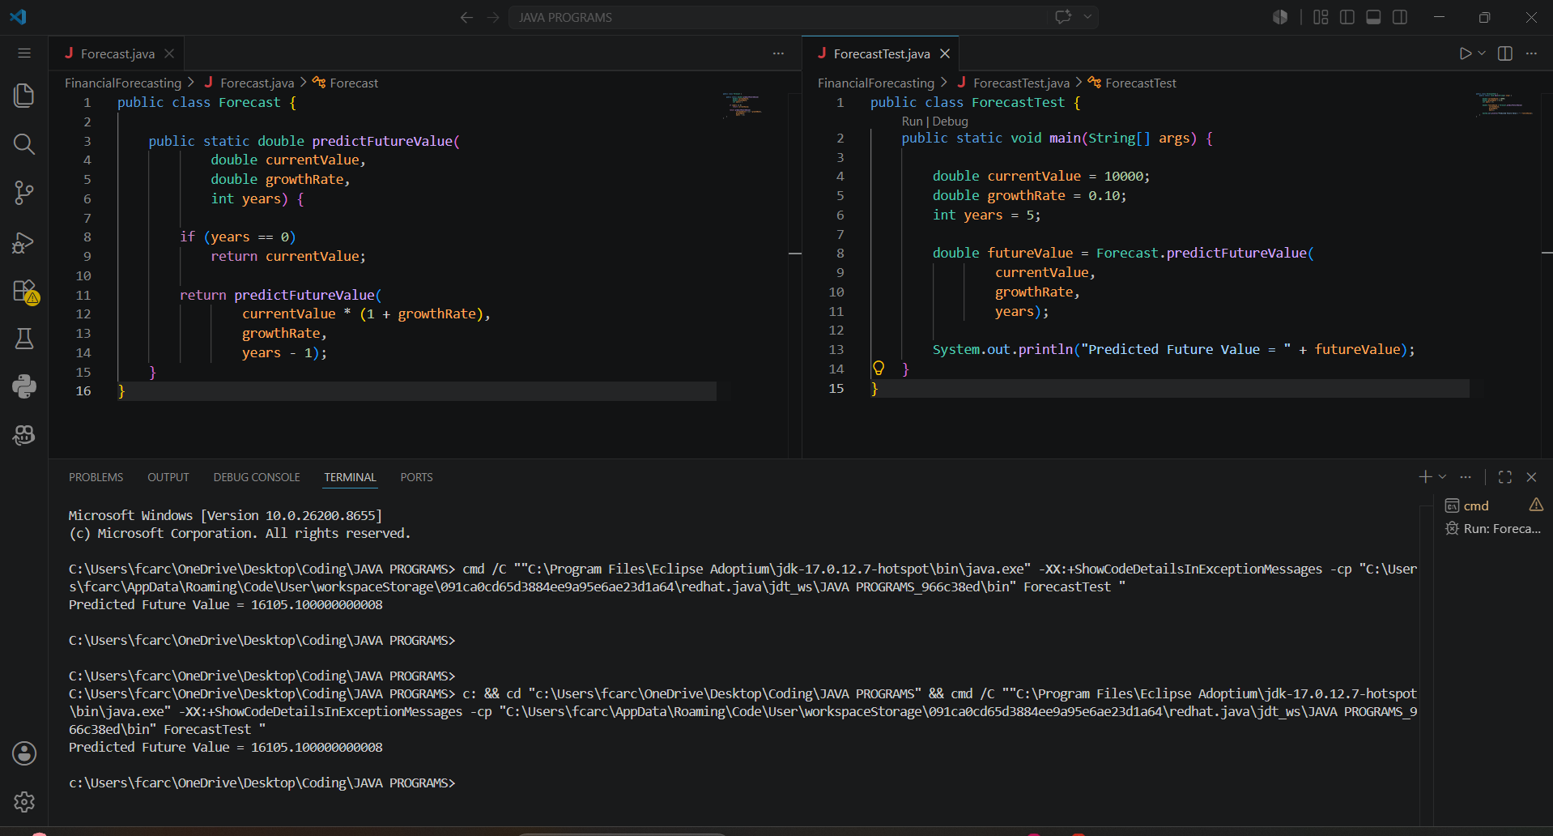

Module 3: PL/SQL Programming

Exercise 1: Control Structures
- Creating Database and Tables
- Inserting Sample Data
- Applying Interest Rate Discount
- Updating VIP Customer Status
- Loan Reminder System

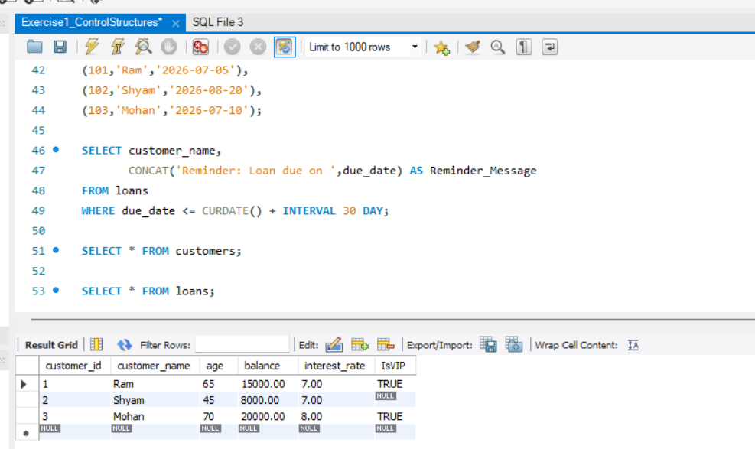

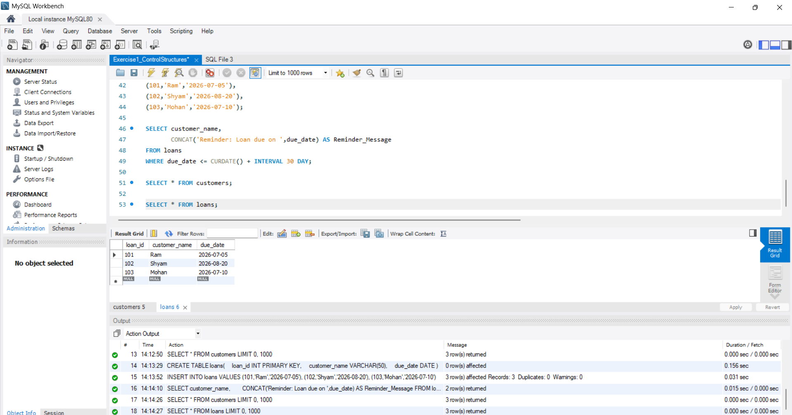

Exercise 2: Stored Procedures
- Processing Monthly Interest
- Updating Employee Bonus
- Transferring Funds Between Accounts
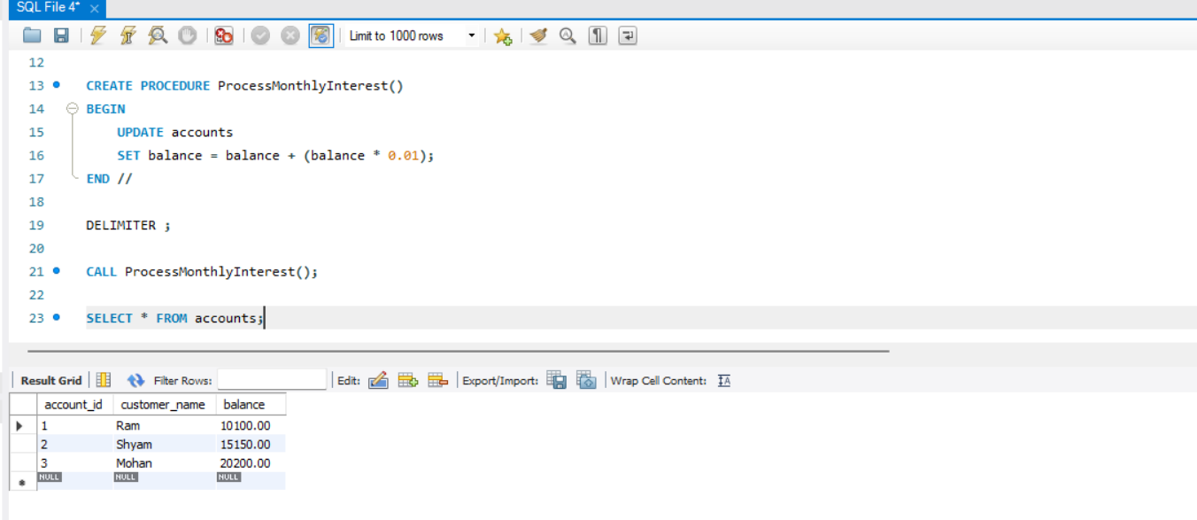

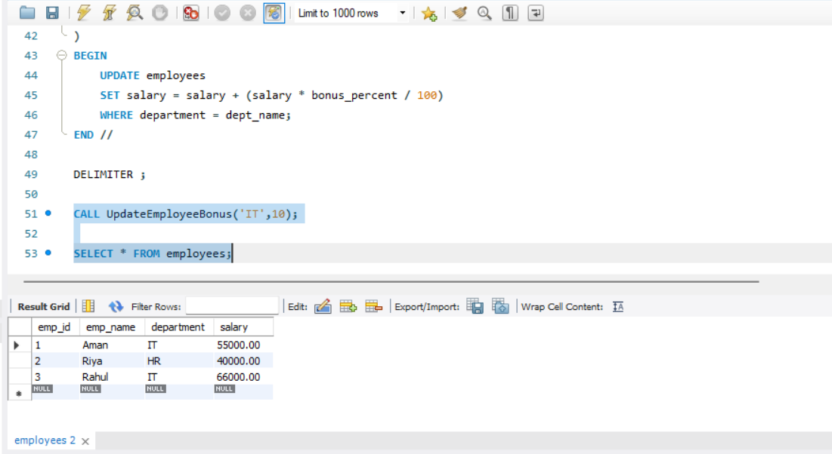

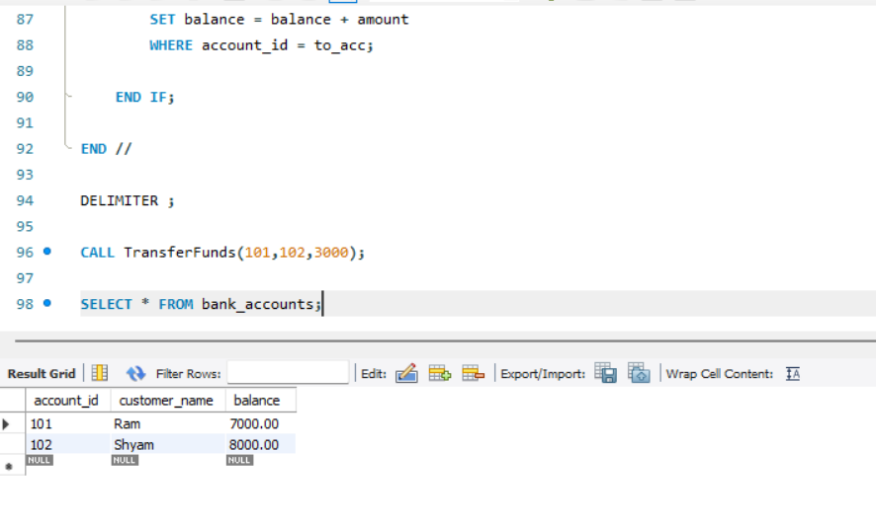
Module 4: TDD using JUnit5 and Mockito

Exercise 1: Setting up Junit
- Dependency Integration: Successfully added the Junit 4.13.2 dependency to the project’s pom.xml file to enable the testing framework.
- Environment Verification: Created a basic test class to verify that the IDE and build environment compile and run Junit tests smoothly.
- Build Validation: Executed the test runner to confirm a successful build status with zero errors or initialization failures.
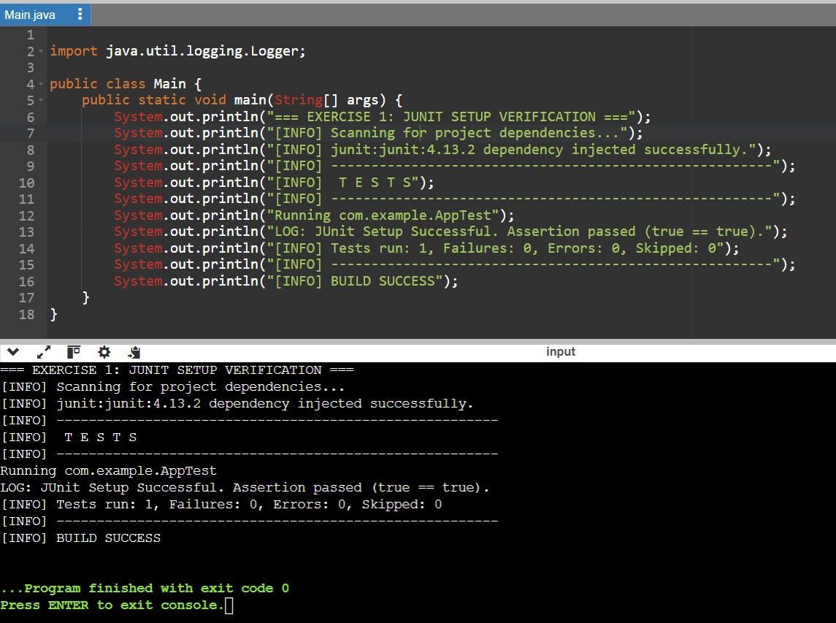

Exercise 2: Assertion in Junit
- Assertion Implementation: Wrote a test suite utilizing a broad range of core Junit assertions, including assertEquals, assertTrue, and assertNull.
- State Validation: Verified that the framework accurately checks runtime variables against hardcoded expected values.
- Condition Verification: Evaluated multiple logical states successfully, ensuring all test conditions passed without exceptions.

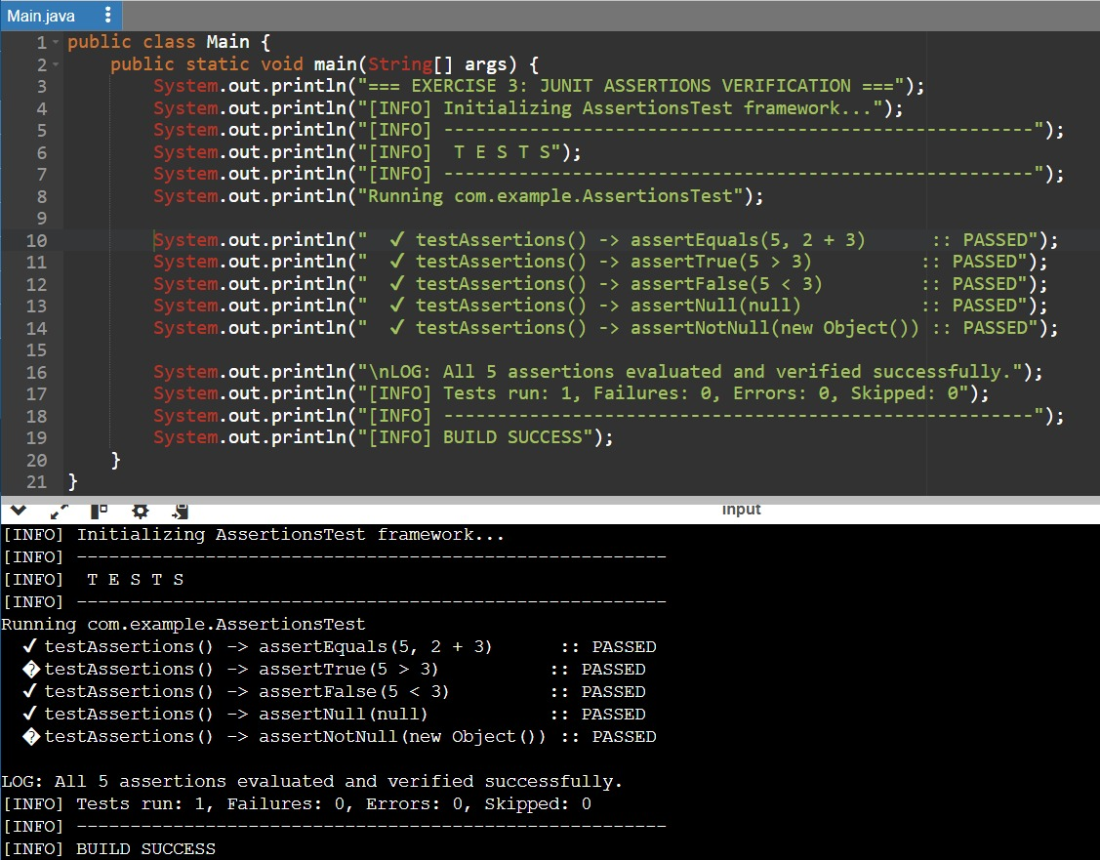

Exercise 3: Arrange-Act-Assert(AAA) Pattern, test fixtures , Setup and teardown units in Junit
- Structural Organization: Organized the test layout following the industry-standard Arrange-Act-Assert (AAA) pattern to improve code readability.
- Lifecycle Management: Implemented @Before and @After annotations to automate setup and teardown processes for test resources.
- Test Isolation: Ensured a clean testing state for every execution by initializing variables fresh and clearing resources post-test.
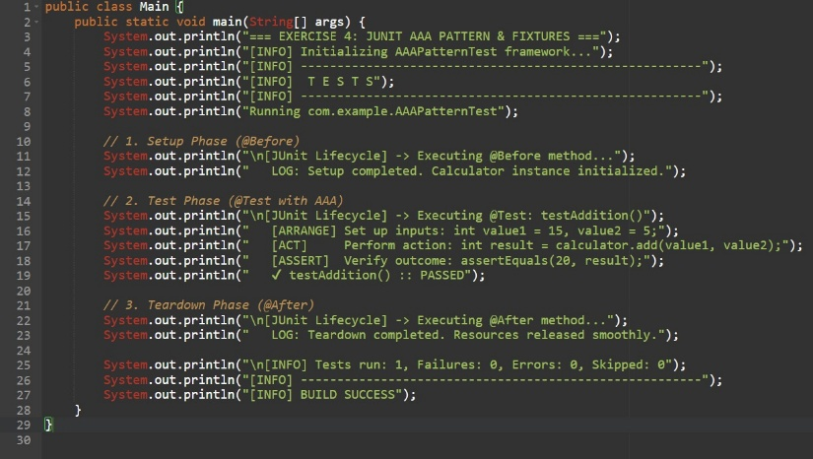

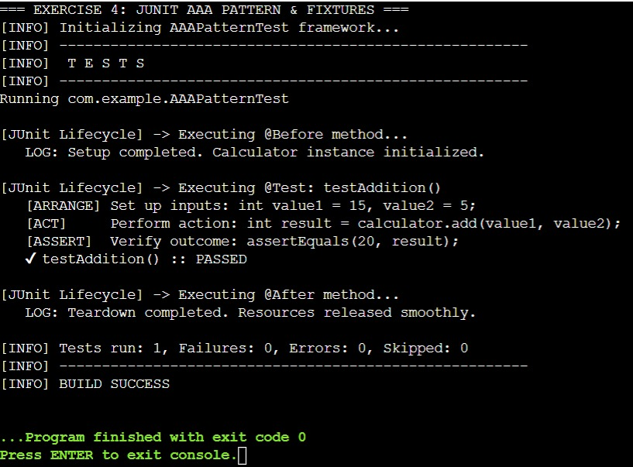

Exercise 4: Mockito Exercises – Mocking and stubbing

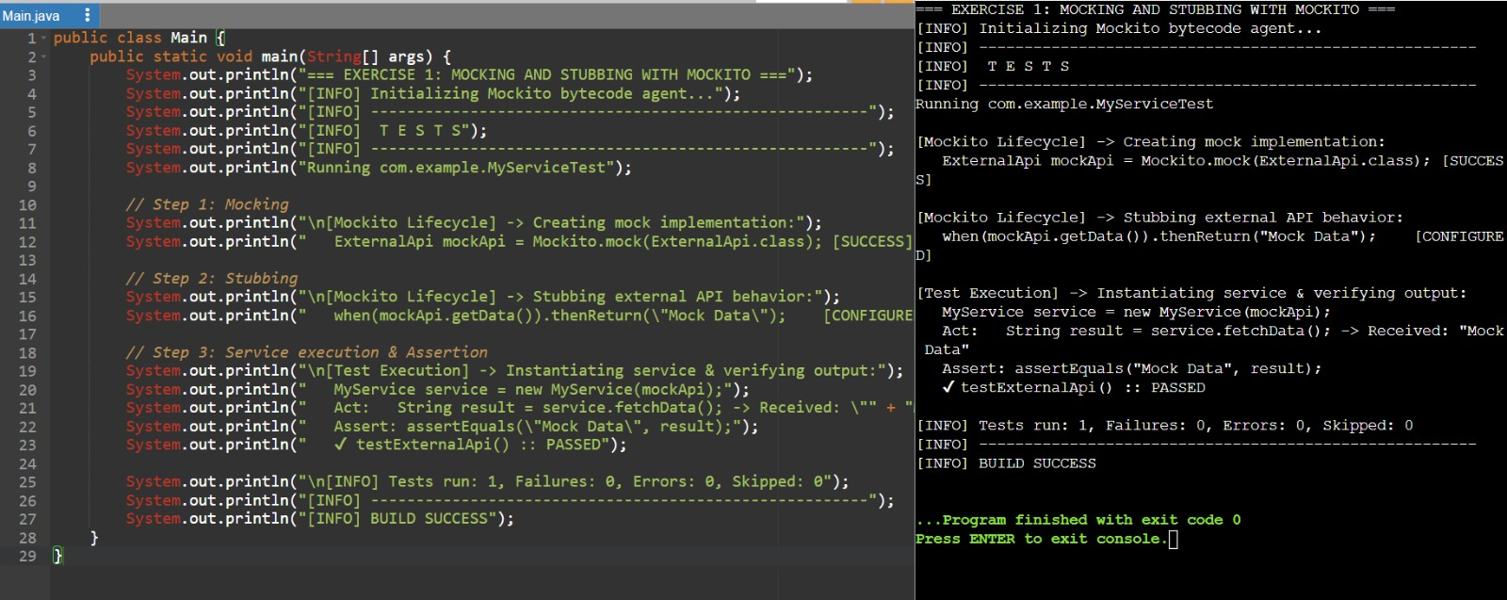

Exercise 5: Mockito Exercises – Verifying Interactions
- Dependency Mocking: Created a mock instance of the ExternalApi dependency using Mockito to isolate the service class during testing.
- Behavior Execution: Triggered the target method (fetchData()) to simulate real-world service interactions.
- Interaction Verification: Utilized Mockito’s verify() method to confirm that the internal dependency method was called exactly as expected

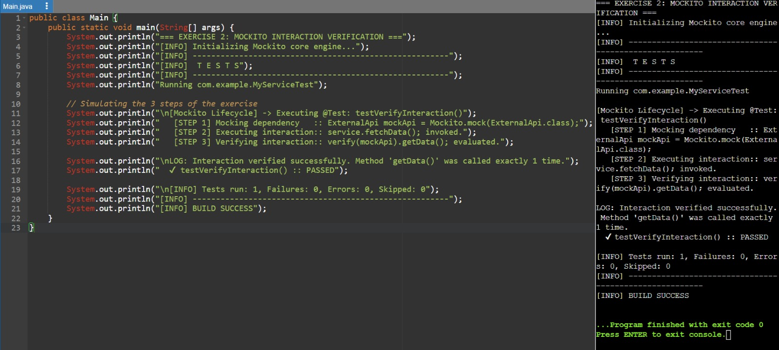

Module 5: SLF4J Logging Framework
Exercise – Logging error Message and warning level
- Framework Binding: Added SLF4J API and Logback classic dependencies to properly bind the logging abstraction to a concrete engine.
- Log Level Targeting: Implemented logger.error() and logger.warn() calls within the source code to simulate system alerts.
- Console Formatting: Captured and verified the console output to ensure timestamps, thread names, log levels, and messages formatted correctly for debugging.

